**Project Report**

**Computational Thinking and Programming (ECSE105L)**

**Currency Converter**



**Bennett University**

**School of Engineering & Applied Sciences**

**Department of Computer Sciences & Information Technology**

**Submitted by:**

**Team Name (Batch Name)**

SARTHAK MAHAJAN E20CSE197

SHREY RAJ E20CSE208

SHRUTI SINHA E20CSE192

SURYA TEJA REDDY E20CSE185

**Feb 2021**

**ACKNOWLEDGEMENT**

While we were making this project, we are glad that we were able to complete this project and was able to understand many things. We take this opportunity to acknowledge all the people who have helped us whole heartedly in every stage of this project. The journey of making this project was so nice and in all this my teachers who supported me all the time, cleared my doubts and my friends that helped me specially in debugging. We are indebtedly grateful to the Mr. Deepak Singh for his support. We are also grateful to our lab instructor Mr. Akash for his valuable guidance. We also extend our sincere thanks to all other faculty members of Computer Science & Engineering Department and the team members of Team 007 that equally contributed to make this project more effective.

A project is a bridge between theoretical and practical learning and with this thinking we worked on the project and made it successful due to timely support and efforts of all who helped us.

**ABSTRACT**

*There are around 200+ different currencies used in different countries around the world. Conversion from one currency to another is a very important endeavor especially when it comes to marketing and travel. The software interface that we are proposing here could be used for various currencies, so it is very important to select the right features and proper algorithm for this purpose. The basic requirements to be considered as practically implementable are simplicity, , high speed and efficiency. Our main aim is to design an easy but efficient algorithm that would be useful for maximum number of currencies and there is a regular update about currency of every country by which it displays present currency market value and conversion rate. This project will basically be designed using Python programming language.*

*Such application can be used by any user, but it is mainly useful for business, shares, and finance related areas where money transfer and currency exchange take place on a daily basis. In this currency converter app, users are provided with an option to select the type of conversion, i.e., from “this” currency to “that” currency. This simple feature allows users to enter amount to be converted (say currency in Dollars) and display the converted amount (say currency in Euro).*

Table of Contents

1 Introduction 1

1.1 Problem Statement 1

1.2 Objectives 1

1.3 Importance and Need of your Project 1

2 Proposed Solution/Approach/Technique 2

2.1 Proposed Methodology 2

3 Project Execution 3

3.1 Project Setup 3

3.2 Results and discussion 3

4 Conclusion and Future Work 4

5 Major Contributions 5

6 References 6

**LIST OF TABLES**

Table 1: Sample 1 3

**LIST OF FIGURES**

Figure 1: Methodology 2

# Introduction

A currency converter, an online application that allows the quick conversion of currencies and their exchange rates. These programs typically use the most recent market prices in the foreign exchange market. It is useful to tourists, multi-national businesses, and forex traders as it helps to determine how much of a base currency people might need while traveling overseas, traders to import/export business to determine the selling and buying profits of various products or to brokers to make informed decisions to minimize risks and maximize returns. This is important because the exchange rate, the price of one currency in terms of another, helps to determine a nation’s economic health and hence the well-being of all the people residing in it.

## Problem Statement

Some of the issues that will come with a currency converter is that it will have to be updated regularly as the world’s currencies constantly fluctuate.

The converter must also be aesthetically pleasing and not look like it has been coded at the last minute with inequalities in the design. If it does not look good the user might have second thoughts about trusting the amounts that the program comes out with.

It must be as user friendly as possible and easy to use by keeping minimal options like currencies, calculators, and live exchange rates, if the converter is too complex to learn then user will be put off using the converter.

## Objectives

Currency converters aim to maintain real-time information on current market or bank exchange rates, so that the calculated result changes whenever the value of either of the component currencies does. It uses the most recent prices to convert in the foreign exchange market as it stores the most recent market valuations of the world’s currencies which allows individuals to compare the value of one currency.

The main objective of the study is to develop a currency converter for major countries in the world. To achieve this objective, specific objectives are laid out which include:

I. Develop a system which able to convert between the currencies.

ii. A system in which the recent conversions be stored as conversion history.

iii. Develop the program that can show the hikes and lows of conversion currency in graphical representation.

iv. A calculator so that the user can calculate the budget.

v. Current trending to check the value of currency with international currencies.

## Importance and Need of your Project

There are people who use a currency converter so that they could keep track of the rates they exchange in an easier and more systematic manner.

It is quite easy to do and understand, these types of converters are very handy is used for identifying the current value of a specific national currency compared to the current value of other national currencies. If the parameters set in it are updated regularly then you will get the right value and shows the fluctuation of the rates in real time. Users need to enter the amount they need to check and the type of currency then the final report will be available in just a matter of seconds.

What is interesting is that there are many people who are interested in working on foreign exchange markets, but it seems that they are not very familiar with currency converters. If you want to trade a currency you will definitely want to know the exact value of that currency no matter if you are buying or selling.

Each strategy and technique of foreign exchange has its own set of pros and cons, so people who wish to convert their money from one currency to another should be well-versed of which one would give them the best rates, and which would be the most beneficial for them. To those who are going to travel for business purposes or for a vacation abroad, it is a wise thing to check the different foreign exchange options they have beforehand. It’s a very helpful software and the best part is that you can usually use them online for free.

# Proposed Solution/Approach/Technique

It includes a wide list of currencies (we are using 33 in our project) so that we can cover a wide range of countries. Building currency converter apps should focus on showing up-to-date exchange rates. A wide variety of currencies will help us to attract a horde of users. It just depends on owner or developer that how many currencies has to be added in the app. If we have a large number of users from specific countries, then we can even pin those country’s currency to avoid the hassle.

The designing of a currency converter application solely depends on the platform that we are targeting. Also, we have considered that the application delivers only the information, so there should not be heavy colour combinations or inclusion of heavy designs or navigation features. Just a simple application with minimalistic design and user-friendly functionality, that’s it. There are countable things that we considered for the development of currency converter app like currencies, calculators, and live exchange rates.

As you have seen the theoretical information for constructing a currency converter application, let’s see how we build it one technically.

During the period where member-nations were transitioning to the Euro from their national currencies, conversions between national currencies were not allowed. All conversions between national currencies had to be done through the Euro and this method has been defined as triangulation. While triangulation methodology was created specific to the introduction of the Euro, triangulation may be used for any currency conversion regardless of whether or not it is related to the Euro.

The requests module provides automation capability for converting one currency into another with our Euro foreign exchange reference rates API.

It provides an easy way to convert currencies using the latest available conversion rates data and a quick way to integrate accurate currency conversion functionality in the software.

## Proposed Methodology

Figure 1: Methodology

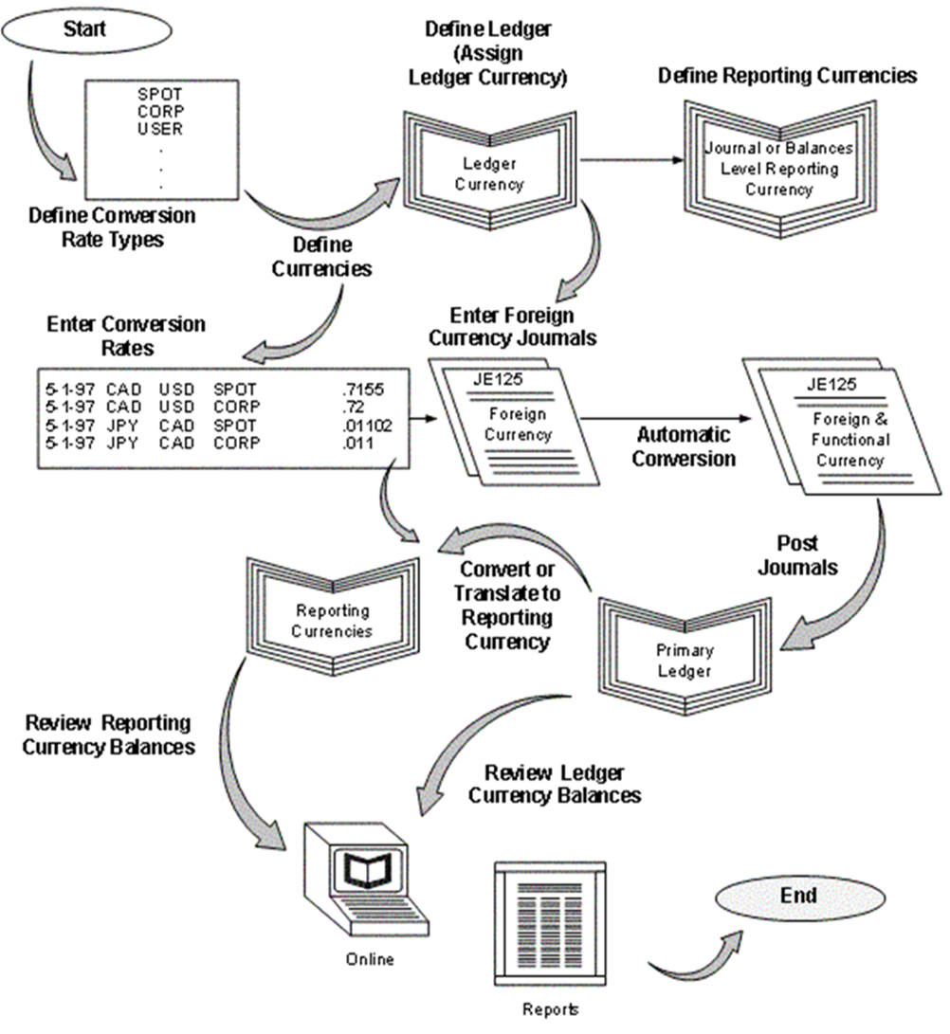

# Project Execution

Currency exchange rates are constantly changing which is why we have decided against the idea of storing all the exchanges rates in our code are these would not remain up-to-date. Instead, we will retrieve up-to-date currency exchange rates by making calls to an API that provides the current rates.

To do so we will use the “Euro foreign exchange reference rates” to retrieve up-to-date exchange rates. This API delivers data in JSON. JSON (JavaScript Object Notation) is a popular lightweight data-interchange format. Its main benefit is that it is easy for humans to read and write and it is easy for machines to parse and generate.

## Project Setup

Table 1:

|  |  |
| --- | --- |
| **#** | **Decision Description** |
| 1 | Server Operation System – Windows NT Server |
| 2 | default Capstone coding standard, Windows NT Workstation |
| 3 | Languages Used: Python 3 |

## Results and discussion

Currency converter that the people are using, they will always find ways to get the highest possible profits out of the exchanges. To those who are going to travel, it is a wise thing to check the different foreign exchange options they have beforehand. At times, a person may get confused if the data provided by the application reliable or is outdated. Especially those who are associated with banks and have to deal with currencies throughout the day. What makes this different than its competitors that it is updated regularly on the basis of hikes and lows of international currency and also presents a graphical representation. So, without a question, this would provide the most reliable data and also has a hassle-free interface to use.

# Conclusion and Future Work

We are looking on into the future to include more number of currencies, and continue as the most reliable currency converter.

# Major Contributions

Shrey: Was the one who come up with the idea of making of this application and helped to find the sources and analyze the way of coding. He coded the interface and added few travel websites to his codes for the application.

Shruti: Being good in surfing, discuss and planned many of the features that can be added to this project and came up with the idea of Graphical Analysis and coded it in such a way that can show the user hikes and lows of any currencies time to time.

Surya: Being the good coder, he develop the calculator for calculating the budget. He implemented some of the new ideas to his own and helped in debugging. He helped others when any of us face difficulties in coding.

Sarthak: Most active member, created window where he coded the currency conversions and current trending so that user can check the status of their national at the same time. He also told what modules need to imported for the purpose.

# References

1)Tkinter — Python interface to Tcl/Tk :Source code: Lib/tkinter/__init__.py:

<https://docs.python.org/3/library/tkinter.html#:~:text=The%20tkinter%20package%20(%E2%80%9CTk%20interface,it%20is%20maintained%20at%20ActiveState.)>  
2) Python - GUI Programming (Tkinter)Tutorials point:

<https://www.tutorialspoint.com/python/python_gui_programming.htm>  
3) European Central Bank :

<https://www.ecb.europa.eu/home/html/index.en.html>